土木工程高峰学科建设申请表格编号：TMGFXK-2017-XXX-[ ]

**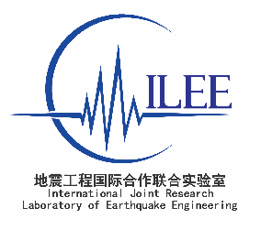**

**地震工程国际合作联合实验室合作研究项目申请书**

**Application for the Collaborative Research Project under**

**International Joint Research Laboratory of Earthquake Engineering**

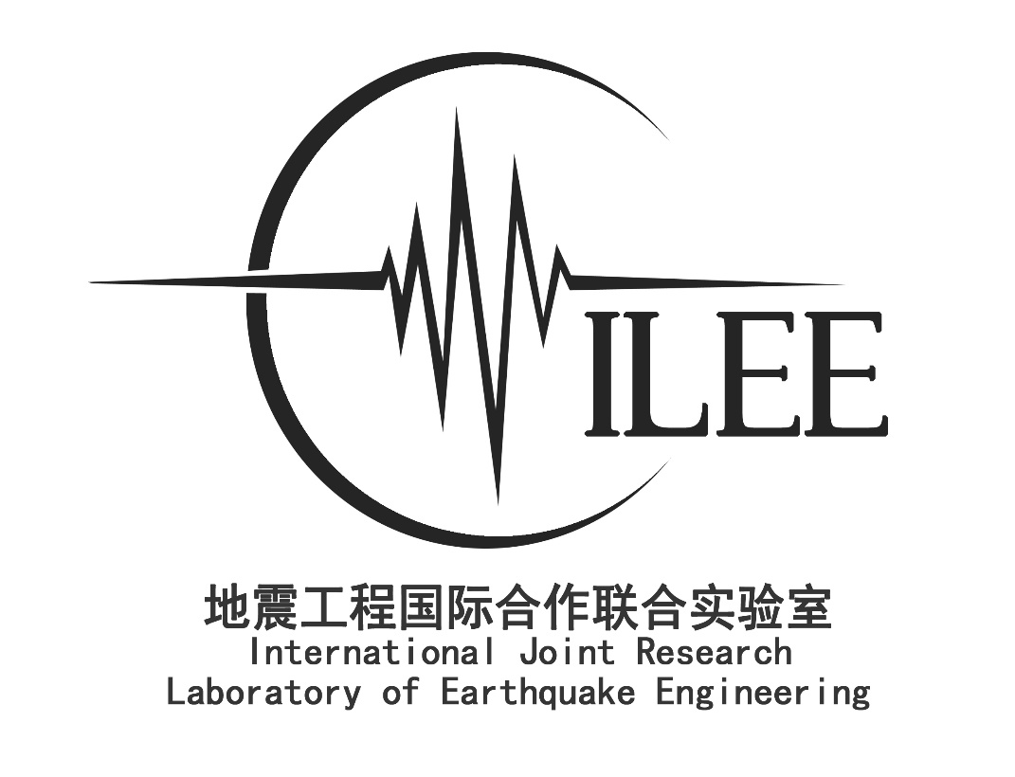

|  |  |
| --- | --- |
| Research title |  |
| Principal investigator (PI) |  |
| PI’s affiliation |  |
| Co-PI at Tongji University |  |
| Date |  |

****

**Descriptions and requirements of application**

1. This is the official application form for the Collaborative Research Project under International Joint Research Laboratory of Earthquake Engineering (ILEE).
2. The PI must be a well-established foreign researcher (non-Chinese passport holder) specialized in earthquake engineering.
3. The co-PI must be a faculty at the College of Civil Engineering at Tongji University, China.
4. The funding for each project is limited to 600,000 RMB. If the project is supported by ILEE affiliated research centers towards the research on the ILEE earthquake resilient rating theme, ILEE will provide an additional matching fund (1:1 ratio) upto 300,000 RMB. The matching fund must be administrated according to the regulation set by Tongji University and used within China.
5. The duration of the research project shall be limited to 3 years.
6. All data generated through this research project shall be appropriately acknowledged. Credit shall be given to the researchers, equipment site, and the International Joint Research Laboratory of Earthquake Engineering.
7. All font shall be Times New Roman with size no less than 12.
8. This form can be downloaded at [www.ilee-tj.com](http://www.ilee-tj.com).
9. Three signed application forms should be sent to Miss Feng Zhang at Room B612, College of Civil Engineering, Tongji University. 1239 Siping Road, Shanghai 200092, China.

FY2017

**Application for the collaborative research project under**

**International Joint Research Laboratory of Earthquake Engineering**

Title of cooperative research project

|  |
| --- |
|  |

Principal Investigator (PI)

Name (Given) (Surname)

Affiliation

Division

Title

Address

Tel

E-Mail

Co-PI at Tongji University

Name (Given) (Surname)

Affiliation

Division

Title

Address

Tel

E-Mail

Proposed period of cooperative research project (up to 3 years)

|  |
| --- |
| Year/Month/Day　-　 Year/Month/Day |

**Abstract – maximum 1 page**

|  |
| --- |
|  |

**Principal investigator’s CV (Including education, past and present positions and membership of relevant organizations/associations and main scientific contributions within the last 5 years) - maximum 3 pages**

|  |
| --- |
|  |

**Co-PI’s CV (Including education, past and present positions and membership of relevant organizations/associations and main scientific contributions within the last 5 years) - maximum 3 pages**

|  |
| --- |
|  |

**Research team**

|  |  |  |
| --- | --- | --- |
| Name |  |  |
| *Example: John Smith* | Title | *Professor, Director of research facility* |
| Degree | *Ph.D.* |
| Affiliation | *Tongji University* |
| Specialization | Earthquake engineer, structural dynamics, concrete structures |
|  | Title |  |
| Degree |  |
| Affiliation |  |
| Specialization |  |
|  | Title |  |
| Degree |  |
| Affiliation |  |
| Specialization |  |
|  | Title |  |
| Degree |  |
| Affiliation |  |
| Specialization |  |
|  | Title |  |
| Degree |  |
| Affiliation |  |
| Specialization |  |

**Descriptions of the cooperative research project – maximum 15 pages**

**Including: 1) Purpose and importance of the research; 2) Description of the current research trend in the field; 3) Detailed description of the joint research project, such as scientific issues targeted, proposed methodologies, use of the ILEE facilities such as the multi-functional shaking tables (Jiading Campus), shaking table (Siping Campus), and centrifuge (Siping Campus) of Tongji University; 4) Description of collaboration from each side in order to realize the project goals; 5) Expected impact of research; including journal and patent publications, students training and technology transfer; 6) Description of the contribution and adaptability of the proposed research towards the ILEE resilient rating system.**

|  |
| --- |
|  |

**Annual work plan/schedule for the cooperative project (with clear description of research activities on both sides as well as of the elements of cooperation and exchange) – maximum 3 pages**

|  |
| --- |
|  |

**Detailed description on the use of the ILEE facilities & funding allocation – maximum 5 pages**

**Budget summary (RMB)**

ILEE facility or facilities to be used:

Description on the use of the ILEE facility or facilities:

Schedule of using the ILEE facility or facilities:

Detailed description of the funding allocation:

Detailed description of matching fund (if applied):

|  |  |  |
| --- | --- | --- |
|  | Amount | Description |
| Equipment/Instruments |  |  |
| Testing materials |  |  |
| Experimental fee |  |  |
| Travel |  |  |
| Workshops/Seminars |  |  |
| International cooperation and exchange |  |  |
| Researchers |  |  |
| Detailed description of matching fund (if applicable). |  |  |
| Total |  |  |

**Deliverables**

|  |  |
| --- | --- |
| 1 | Published 2 or more co-authored SCI journal papers. Provide recognition to the ILEE financial support. |
| 2 | Publish 1 ILEE report. |
| 3 | Give oral presentation of ILEE project during ILEE annual meeting. |
| 4 | Upload raw and post-processed data to ILEE repository no later than 9 months after the project end date. |

**Signatures**

**Signatures of persons in PI and Co-PI, dates and places (“I assure that the information I have presented in this application and its appendices is correct and that all the factors essential for the processing of the application have been included. I undertake the responsibility that, in the event that ILEE grants funding, the funds will be used for the purpose for which they have been granted, the project will be conducted as planned and the reports required by ILEE will be submitted.”)**

|  |  |  |  |
| --- | --- | --- | --- |
| PI |  |  |  |
| Printed Name | 签字/Signature | 日期和地点/Date and place |

|  |  |  |  |
| --- | --- | --- | --- |
| Co-PI |  |  |  |
| Printed Name | 签字/Signature | 日期和地点/Date and place |

**Review comments:**

|  |  |  |  |  |  |  |  |  |
| --- | --- | --- | --- | --- | --- | --- | --- | --- |
| A. Contribution to ILEE research theme – Earthquake resilient rating system | | | | | | | | |
| Excellent |  | Good |  | Adequate |  | Insufficient |  | |
| Score: /25 | | | | | | | | |
| Comments: | | | | | | | | |
| B. Excellence of researchers | | | | | | | | |
| Excellent |  | Good |  | Adequate |  | Insufficient |  | |
| Score: /10 | | | | | | | | |
| Comments: | | | | | | | | |
| C. Strength of collaboration | | | | | | | | |
| Excellent |  | Good |  | Adequate |  | Insufficient |  | |
| Score: /15 | | | | | | | | |
| Comments: | | | | | | | | |
| D. Excellence of the research methodology   * Clarity and innovation of the research approach * Use of ILEE facilities | | | | | | | | |
| Excellent |  | Good |  | Adequate |  | Insufficient | |  |
| Score: /30 | | | | | | | | |
| Comments: | | | | | | | | |
| F. International impact | | | | | | | | |
| Excellent |  | Good |  | Adequate |  | Insufficient | |  |
| Score: /20 | | | | | | | | |
| Comments: | | | | | | | | |
| Total Score: | | | | | | | | |

|  |  |  |  |  |  |
| --- | --- | --- | --- | --- | --- |
| G. Execution | | | | | |
| Budget | | | | | |
| Appropriate |  | Minor modification |  | Major modification |  |
| Comments: | | | | | |
| Schedule | | | | | |
| Appropriate |  | Minor modification |  | Major modification |  |
| Comments: | | | | | |

|  |  |  |  |
| --- | --- | --- | --- |
| Reviewer |  |  |  |
| Printed Name | Signature | Date and place |

**Appendix: ILEE facilities (**[**http://www.ilee-tj.com/**](http://www.ilee-tj.com/)**)**

|  |  |
| --- | --- |
| #1 | Multi-functional shake table |
| Location | Jiading Campus |
| Description | The multi-functional shake table consists of four 6m x 4m shaking tables. Each of the table has 2 horizontal translational degrees of freedom. The tables are situated in two trenches (70 m and 30 m). |
| Capacities | |  |  |  |  | | --- | --- | --- | --- | | Table | Table A and D | | Table B and C | | Table dimension | 6m×4m | | | | Largest payload | 30 ton | | 70 ton | | Degrees of freedom | 2 horizontal degrees of freedom. | | | | Displacement | 500mm both horizontal directions | | | | Velocity | 1000mm/s both horizontal directions | | | | Acceleration | 1.5g both horizontal directions | | | | Frequency | 0.1 ~50 Hz | | | | Base moment | 200 ton∙m | 400 ton∙m | | |
| Picture 1 | 多点振动台2 |
| Picture 2 | 泰州长江大桥 |
| Test charge | |  |  |  |  | | --- | --- | --- | --- | |  | Item | Cost | | | Shaking table usage fee | Moving table fee | 30 Ton table: 10000 RMB/Table | | | 70 Ton table: 15000 RMB/Table | | | Table usage fee (Occupied) | 30 Ton table: 2400 RMB/Day | | | 70 Ton table: 3600 RMB/Day | | | Table usage fee (Testing) | 30 Ton table | < 50 channels: 24000 RMB/Table/Day | | Channels < 100: 30000 RMB/Table/Day | | Channels < 200: 36000 RMB/Table/Day | | Channels < 288: 42000 RMB/Table/Day | | 70 Ton table | < 50 channels: 36000 RMB/Table/Day | | Channels < 100: 42000 RMB/Table/Day | | Channels < 200: 48000 RMB/Table/Day | | Channels < 288: 54000 RMB/Table/Day | | Equipment rental | Strain | 50 RMB/Channel/Day | | | Displacement | 100 RMB/Channel/Day | | | Acceleration | 100 RMB/Channel/Day | | | Other fee | Material testing | Full stress-strain curve: 100 RMB/Piece | | | Only yield capacity: 30 RMB/Piece | | | Overtime fee | 300 RMB/Person/Day. (hours outside regular office hour 8 am -5 pm on weekday) | | | Clean up fee | Case dependent | | |

|  |  |  |  |  |
| --- | --- | --- | --- | --- |
| #2 | HTS Electro-hydraulic Servo Test System | | | |
| Location | Jiading Campus | | | |
| Description | HTS servo test system contains four high-speed actuators. | | | |
| Capacities | Actuator | Max. Force (kN) | Stroke (mm) | Velocity (mm/s) |
| 2×1,000kN | 1,000 | ± 200 | 200 |
| 1×300kN | 300 | ± 250 | 600 |
| Picture | 说明: I:\UH与同济合作\重点实验室开放课题\项目实施\2014年第二批\shear column 2\pictures\SDC11141.JPG  IMG_4238 | | | |
| Test charge | About 12,000 RMB per specimen. The fabrication fee of the specimen is charged according to its actual cost. | | | |

|  |  |  |  |  |
| --- | --- | --- | --- | --- |
| #3 | Large Scale damper testing system | | | |
| Location | Jiading Campus | | | |
| Description | HTS servo test system contains four high-speed actuators. | | | |
| Capacities | Actuator Type | Max. Force (kN) | Stroke (mm) | Velocity (mm/s) |
| 1×2,000kN | 2,000 | ± 600 | 1,200 |
| Picture | 说明: J:\RESEARCH PAPERS\已结题或发表\200T投结构工程师\封面照片\SDC1.JPG  IMG_4229 | | | |
| Test charge | About 20,000 ~ 60,000 RMB per viscous damper. | | | |

|  |  |  |  |  |
| --- | --- | --- | --- | --- |
| #4 | Shenck Electro-hydraulic Servo Test System | | | |
| Location | Siping Road Campus | | | |
| Description | Shenck Electro-hydraulic Servo Test System contains three actuators, a power station and a controller. Most structural components can be tested by this facility, such as columns, walls and joints. | | | |
| Capacities | Actuator Type | Max. Force (kN) | Stroke (mm) | Velocity (mm/s) |
| 2×630 kN | 630 | ± 250 | 100 |
| 1×1000 kN | 1,000 | ± 200 | 100 |
| Picture 1 | 说明: L:\sony_dsc\试验杂图\2003年\2003_2\DSC01277.JPG  Actuators | | | |
| Picture 2 | 说明: L:\sony_dsc\试验杂图\2004年\2004-4-23\DSC02652.JPG  Hybrid test of bridge pier | | | |
| Picture 3 | 说明: L:\sony_dsc\试验杂图\2003年\2003-3-11\DSC01275-1.JPG  Static test of column-beam joint | | | |
| Picture 4 | 说明: L:\sony_dsc\试验杂图\2004年\2004-6\DSC02834.JPG  Revesed cyclic test of steel frame | | | |
| Test charge | About 10,000 RMB per day. The fabrication fee of specimen is charged according to its actual cost. | | | |

|  |  |  |  |  |
| --- | --- | --- | --- | --- |
| #5 | 20000kN Double-shear Rubber Bearing Tester | | | |
| Location | Siping Road Campus | | | |
| Description | This tester was equipped for testing the performance of various rubber bearings. Some vertical-bearing specimen, such as column with a height of no more than 2.0 m, also can be tested by this tester. | | | |
| Test Capacities | Max. Vertical  Force (kN) | Max. Horizontal  Force (kN) | Horizontal Stroke (mm) | Max. size of specimen (mm) |
| 20,000 | 4000 | ±450 | 1,500×1,500×2,000 |
| Picture 1 | 说明: L:\sony_dsc\试验杂图\2014年\11-2000T压剪机\SDC11325.JPG | | | |
| Test charge | About 3,000 ~ 20,000 RMB, according to the size of the rubber bearing. | | | |

|  |  |  |
| --- | --- | --- |
| #6 | 800kN Metal Damper Tester | |
| Location | Siping Road Campus | |
| Description | Especially equipped for metal damper test. | |
| Capacities | Max. Shear Force (kN) | Displacement (mm) |
| 800 | ± 200 |
| Picture 1 | 说明: IMG_1601  Metal damper tester | |
| Test charge | 20,000 RMB per specimen. | |

|  |  |
| --- | --- |
| #7 | Shaking table facility |
| Location | Siping Road Campus |
| Description | MTS shaking table. |
| Capacities | Dimension: 4.0 m×4.0 m  Highest payload: 25 Ton  Working frequency: 0.1~50Hz  Degree of freedom: 6 degree of freedom  Sampling channel: 128  **Performance under 15 Ton payload**   |  |  |  |  | | --- | --- | --- | --- | | Direction | Max acceleration | Mac Velocity | Max Displacement | | X | 1.2g | 1000mm/s | 100mm | | Y | 0.8g | 600mm/s | 50mm | | Z | 0.7g | 600mm/s | 50mm | |
| Picture 1 |  |
| Picture 2 | IMG_4246 |
| Test charge | |  |  |  | | --- | --- | --- | |  | Item | Cost | |  | Lab space occupied fee | 3.125 RMB /square meter/day | | Table usage fee | Table usage fee (Occupied) | 2000 RMB/Day | | Table usage fee (Testing) | < 40 channels: 20000 RMB/Table/Day | | Channels < 80: 25000 RMB/Table/Day | | Channels < 128: 32000 RMB/Table/Day | | Equipment rental | Strain | 80 RMB/Channel/Day | | Displacement | 80 RMB/Channel/Day | | Acceleration | 40 RMB/Channel/Day | | Other fee | Material testing | Full stress-strain curve: 100 RMB/Piece | | Only yield capacity: 30 RMB/Piece | | Overtime fee (hours outside regular office hour 8 am -5 pm on weekday) | 300 RMB/Person/Day | | Clean up fee | Case dependent | |

|  |  |
| --- | --- |
| #8 | Centrifuge Shaking Table |
| Location | Siping Road Campus |
| Description | 1D Centrifuge Shaking Table |
| Capacities | Main specifications of Geotechnical Centrifuge   |  |  |  | | --- | --- | --- | | Main Capacity | Effective radius | 3.0m | | Max speed of rotation | 244rpm | | Main motor | 250kW | | Maximum acceleration | 200g | | Maximum payload | 1.5MN | | Platform size | Length | 1.6m | | Width | 1.25m | | Height | 2.17m | | Data Acquisition | Static test | 40 channels | | Dynamic test | 32 channels |   Main specifications of the Centrifuge Shaking Table   |  |  | | --- | --- | | **Max. Acc.** | **amax=20g** | | Max. Velocity | Vmax=38cm/s | | Max. Disp. | Amax=±6mm | | Frequency | f=20～200Hz | | Payload | Mmax=300kg | | Wave | Sine Wave, Earthquake wave | | Time Duration | 1 second | |
| Picture 1 | **Geotechnical centrifuge 1D Centrifuge shaking table Laminar box** |
| Test charge | |  |  |  | | --- | --- | --- | |  | Item | Cost | | Centrifuge test fee | Each test case | Above 9000 RMB each case (should be discussed on each specific case) | | Equipment rental | Strain | Should be prepared by clients | | Displacement | Above 800RMB/channel (for laser displacement transducer) | | Acceleration | Above 600RMB/channel | |