土木工程高峰学科建设申请表格编号：TMGFXK-2025-XXX-[ ]

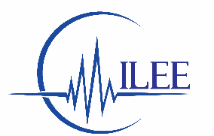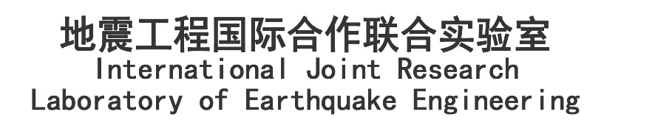

地震工程国际合作联合实验室合作研究项目申请书
Application for the Collaborative Research Project under
International Joint Research Laboratory of Earthquake Engineering

Research title
Principal investigator (PI)
PI’s affiliation
Co-PI at Tongji University
Date

Descriptions and requirements of application

- This is the official application form for the Collaborative Research Project under International Joint Research Laboratory of Earthquake Engineering (ILEE).
- The PI must be an internationally acclaimed researcher specialized in earthquake engineering. Researchers from ILEE member organizations (see the following organization names in the end) will be in priority to apply for the Collaborative Research project as a Principal Investigator (PI).
- The PI must find a Co-PI in the College of Civil Engineering in Tongji University as a collaborator to apply for the Collaborative Research project.
- The duration of the research project shall be limited to 2 years.
- The funding for each project is limited to 400,000 RMB. The project with matching funding will be considered in high priority.
- The research project should be targeted to the international remarkable outcome.
- The use of experimental facility of the State Key Laboratory of Disaster Reduction in Civil Engineering is highly encouraged.
- All data generated through this research project shall be appropriately acknowledged and collected as a dataset to be uploaded in the data warehouse in ILEE website.
- A research report should be submitted to ILEE after the completion of the project and will be uploaded in ILEE website. The published paper from this project should be appropriately acknowledged and is encouraged to be submitted to the journals at the Journal Center of College of Civil Engineering, Tongji University.

FY2025
Application for the collaborative research project under
International Joint Research Laboratory of Earthquake Engineering

Title of cooperative research project

Principal Investigator (PI)
Name (Given) (Surname)
Affiliation
Division
Title
Address
Tel
E-Mail

Co-PI at Tongji University
Name (Given) (Surname)
Affiliation
Division
Title
Address
Tel
E-Mail

Proposed period of cooperative research project (up to 3 years)
Year/Month/Day - Year/Month/Day

Abstract – maximum 1 page

Principal investigator’s CV (Including education, past and present positions and membership of relevant organizations/associations and main scientific contributions within the last 5 years) - maximum 3 pages
[Professional Experience]:

[Education]:

[Memberships in Professional Societies]

[Academic Award]

Co-PI’s CV (Including education, past and present positions and membership of relevant organizations/associations and main scientific contributions within the last 5 years) - maximum 3 pages
[Professional Experience]:

[Education]:

[Memberships in Professional Societies]

[Academic Award]

Research team
Name

Name

Descriptions of the cooperative research project – maximum 15 pages
Including: 1) Purpose and importance of the research; 2) Description of the current research trend in the field; 3) Detailed description of the joint research project, such as scientific issues targeted, proposed methodologies, use of the ILEE facilities such as the multi-functional shaking tables (Jiading Campus), shaking table (Siping Campus), and centrifuge (Siping Campus) of Tongji University; 4) Description of collaboration from each side in order to realize the project goals; 5) Expected impact research impact on the corresponding research area.

Annual work plan/schedule for the cooperative project (with clear description of research activities on both sides as well as of the elements of cooperation and exchange) – maximum 3 pages

Detailed description on the use of the ILEE facilities & funding allocation – maximum 5 pages
Budget summary (RMB)

 | Amount | Description
Equipment/Instruments
Testing materials
Experimental fee
Travel
Workshops/Seminars
International cooperation and exchange
Researchers
Detailed description of matching fund (if applicable).
Total

Deliverables
1
2
3
4

Signatures
Signatures of persons in PI and Co-PI, dates and places (“I assure that the information I have presented in this application and its appendices is correct and that all the factors essential for the processing of the application have been included. I undertake the responsibility that, in the event that ILEE grants funding, the funds will be used for the purpose for which they have been granted, the project will be conducted as planned and the reports and dataset required by ILEE will be submitted.”)

PI
PI | Printed Name | 签字/Signature | 日期和地点/Date and place

Co-PI
Co-PI | Printed Name | 签字/Signature | 日期和地点/Date and place

Review comments:

A. Contribution to ILEE research theme – Earthquake resilience
Excellent | ☐ | Good | ☐ | Adequate | ☐ | Insufficient | ☐
Score: /25
Comments:
B. Excellence of researchers
Excellent | ☐ | Good | ☐ | Adequate | ☐ | Insufficient | ☐
Score: /10
Comments:
C. Strength of collaboration
Excellent | ☐ | Good | ☐ | Adequate | ☐ | Insufficient | ☐
Score: /15
Comments:
D. Excellence of the research methodology
- Clarity and innovation of the research approach
- Use of ILEE facilities
Excellent | ☐ | Good | ☐ | Adequate | ☐ | Insufficient |  | ☐
Score: /30
Comments:
F. International impact
Excellent | ☐ | Good | ☐ | Adequate | ☐ | Insufficient |  | ☐
Score: /20
Comments:

Total Score:

G. Execution
Budget
Appropriate | ☐ | Minor modification | ☐ | Major modification | ☐
Comments:

Schedule
Appropriate | ☐ | Minor modification | ☐ | Major modification | ☐
Comments:

Reviewer

Reviewer | Printed Name | Signature | Date and place

Appendix: ILEE facilities (http://www.ilee-tj.com/)
#1 | Multi-functional shake table
Location | Jiading Campus
Description | The multi-functional shake table consists of four 6m x 4m shaking tables. Each of the table has 2 horizontal translational degrees of freedom. The tables are situated in two trenches (70 m and 30 m).
Capacities
  Table | Table A and D |  | Table B and C
  Table dimension | 6m×4m
  Largest payload | 30 ton |  | 70 ton
  Degrees of freedom | 2 horizontal degrees of freedom.
  Displacement | 500mm both horizontal directions
  Velocity | 1000mm/s both horizontal directions
  Acceleration | 1.5g both horizontal directions
  Frequency | 0.1 ~50 Hz
  Base moment | 200 ton∙m | 400 ton∙m
Picture 1 | 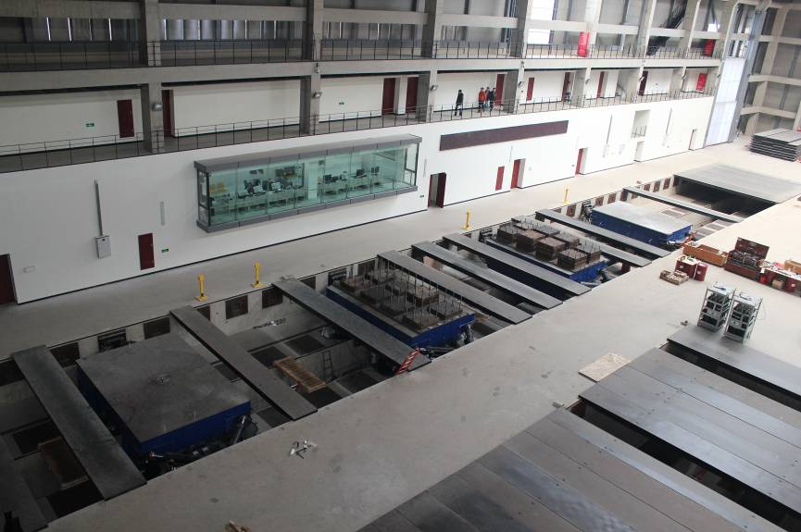  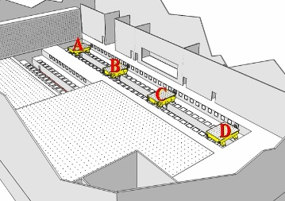  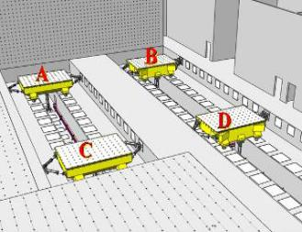  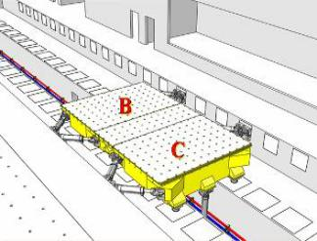
Picture 2 | 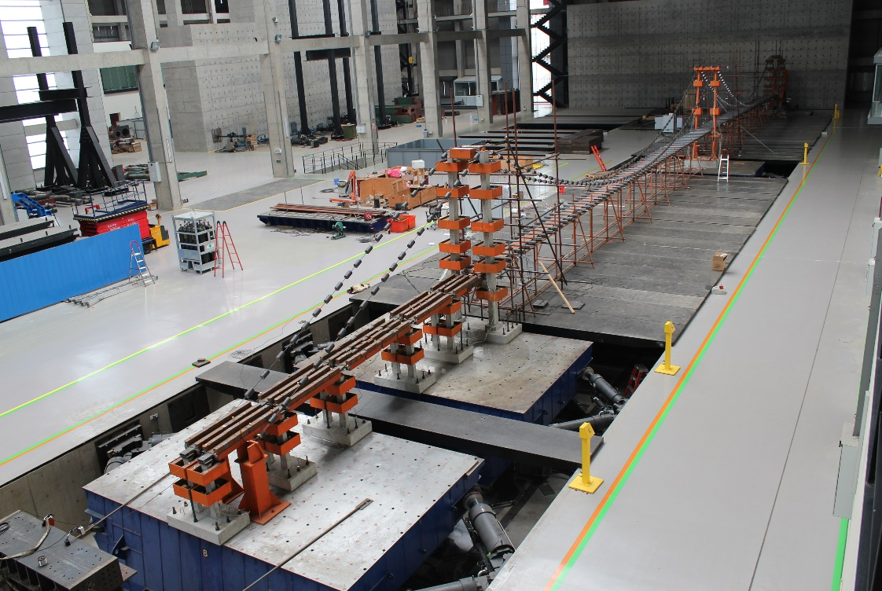
Test charge
   | Item | Cost
  Shaking table usage fee | Moving table fee | 30 Ton table: 10000 RMB/Table
  Shaking table usage fee | Moving table fee | 70 Ton table: 15000 RMB/Table
  Shaking table usage fee | Table usage fee (Occupied) | 30 Ton table: 2400 RMB/Day
  Shaking table usage fee | Table usage fee (Occupied) | 70 Ton table: 3600 RMB/Day
  Shaking table usage fee | Table usage fee (Testing) | 30 Ton table | < 50 channels: 24000 RMB/Table/Day
  Shaking table usage fee | Table usage fee (Testing) | 30 Ton table | Channels < 100: 30000 RMB/Table/Day
  Shaking table usage fee | Table usage fee (Testing) | 30 Ton table | Channels < 200: 36000 RMB/Table/Day
  Shaking table usage fee | Table usage fee (Testing) | 30 Ton table | Channels < 288: 42000 RMB/Table/Day
  Shaking table usage fee | Table usage fee (Testing) | 70 Ton table | < 50 channels: 36000 RMB/Table/Day
  Shaking table usage fee | Table usage fee (Testing) | 70 Ton table | Channels < 100: 42000 RMB/Table/Day
  Shaking table usage fee | Table usage fee (Testing) | 70 Ton table | Channels < 200: 48000 RMB/Table/Day
  Shaking table usage fee | Table usage fee (Testing) | 70 Ton table | Channels < 288: 54000 RMB/Table/Day
  Equipment rental | Strain | 50 RMB/Channel/Day
  Equipment rental | Displacement | 100 RMB/Channel/Day
  Equipment rental | Acceleration | 100 RMB/Channel/Day
  Other fee | Material testing | Full stress-strain curve: 100 RMB/Piece
  Other fee | Material testing | Only yield capacity: 30 RMB/Piece
  Other fee | Overtime fee | 300 RMB/Person/Day. (hours outside regular office hour 8 am -5 pm on weekday)
  Other fee | Clean up fee | Case dependent

#2 | HTS Electro-hydraulic Servo Test System
Location | Jiading Campus
Description | HTS servo test system contains four high-speed actuators.
Capacities | Actuator | Max. Force (kN) | Stroke (mm) | Velocity (mm/s)
Capacities | 2×1,000kN | 1,000 | ± 200 | 200
Capacities | 1×300kN | 300 | ± 250 | 600
Picture | 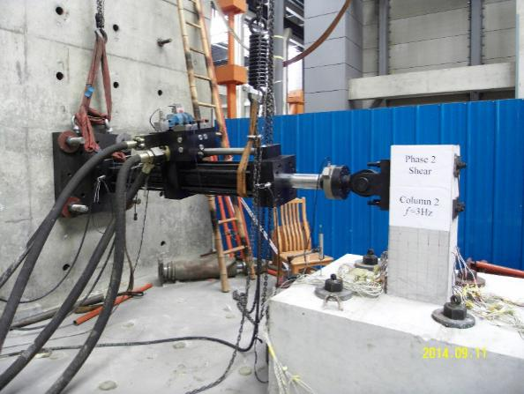  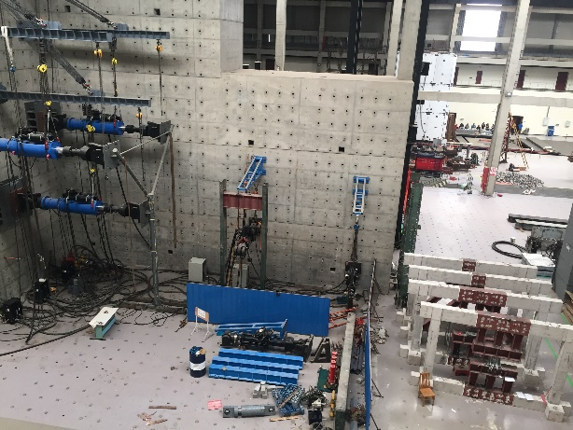
Test charge | About 12,000 RMB per specimen. The fabrication fee of the specimen is charged according to its actual cost.

#3 | Large Scale damper testing system
Location | Jiading Campus
Description | HTS servo test system contains four high-speed actuators.
Capacities | Actuator Type | Max. Force (kN) | Stroke (mm) | Velocity (mm/s)
Capacities | 1×2,000kN | 2,000 | ± 600 | 1,200
Picture | 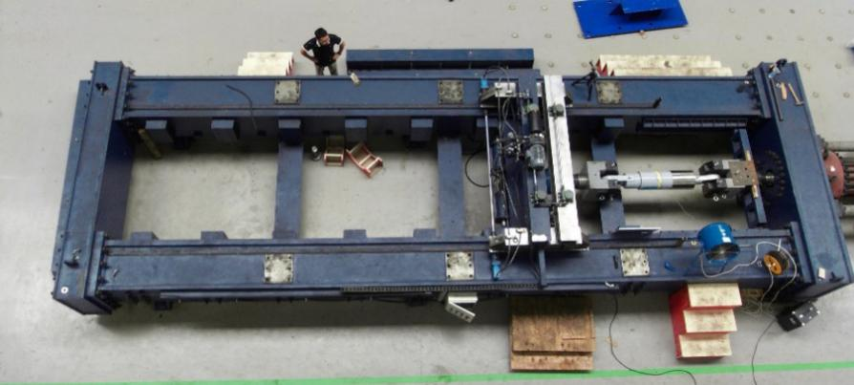  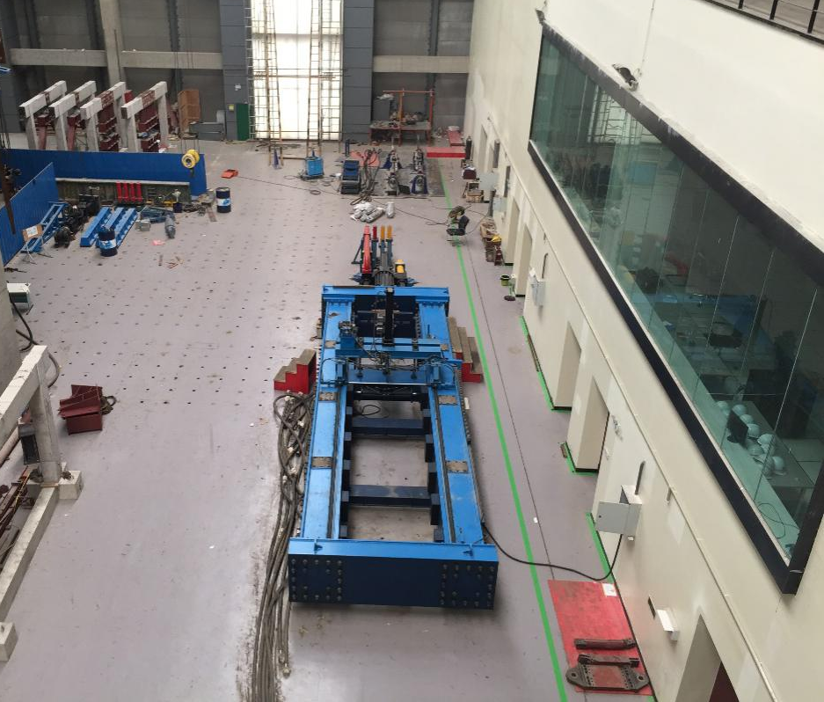
Test charge | About 20,000 ~ 60,000 RMB per viscous damper.

#4 | Shenck Electro-hydraulic Servo Test System
Location | Siping Road Campus
Description | Shenck Electro-hydraulic Servo Test System contains three actuators, a power station and a controller. Most structural components can be tested by this facility, such as columns, walls and joints.
Capacities | Actuator Type | Max. Force (kN) | Stroke (mm) | Velocity (mm/s)
Capacities | 2×630 kN | 630 | ± 250 | 100
Capacities | 1×1000 kN | 1,000 | ± 200 | 100
Picture 1 | 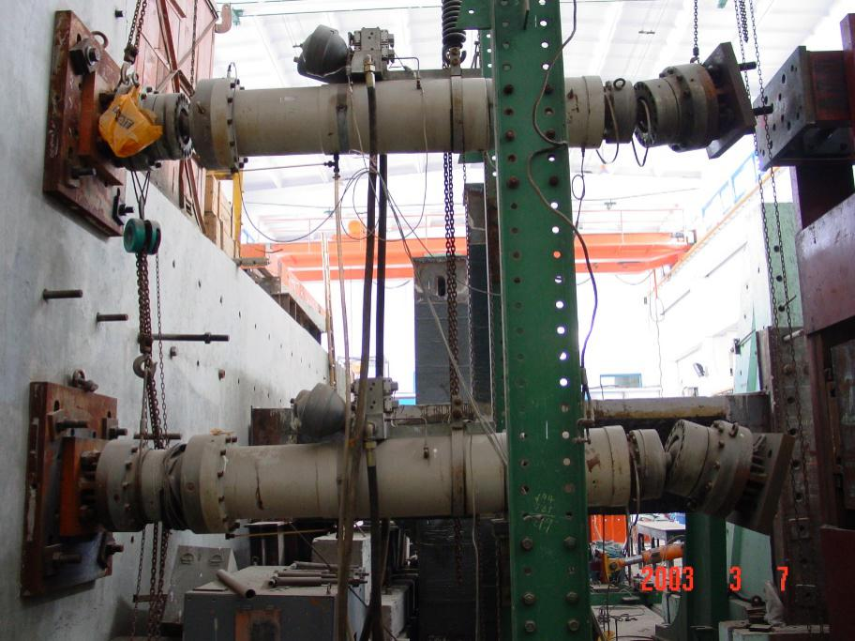  Actuators
Picture 2 | 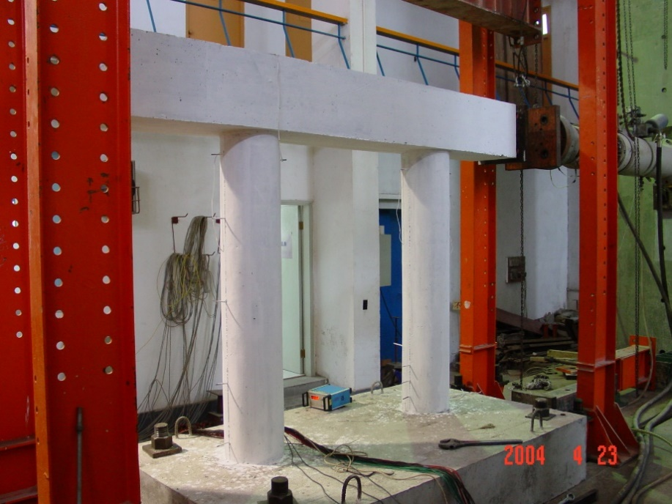  Hybrid test of bridge pier
Picture 3 | 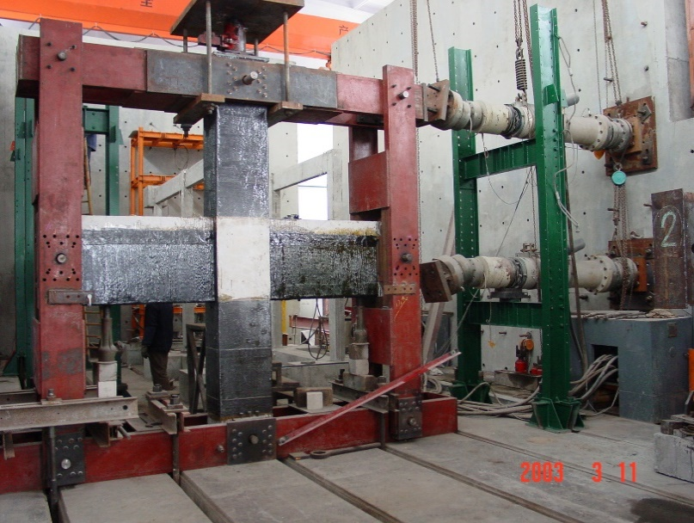  Static test of column-beam joint
Picture 4 | 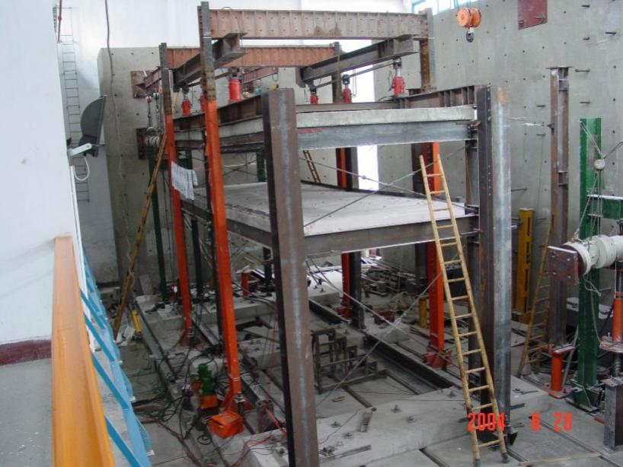  Revesed cyclic test of steel frame
Test charge | About 10,000 RMB per day. The fabrication fee of specimen is charged according to its actual cost.

#5 | 20000kN Double-shear Rubber Bearing Tester
Location | Siping Road Campus
Description | This tester was equipped for testing the performance of various rubber bearings. Some vertical-bearing specimen, such as column with a height of no more than 2.0 m, also can be tested by this tester.
Test Capacities | Max. Vertical  Force (kN) | Max. Horizontal  Force (kN) | Horizontal Stroke (mm) | Max. size of specimen (mm)
Test Capacities | 20,000 | 4000 | ±450 | 1,500×1,500×2,000
Picture 1 | 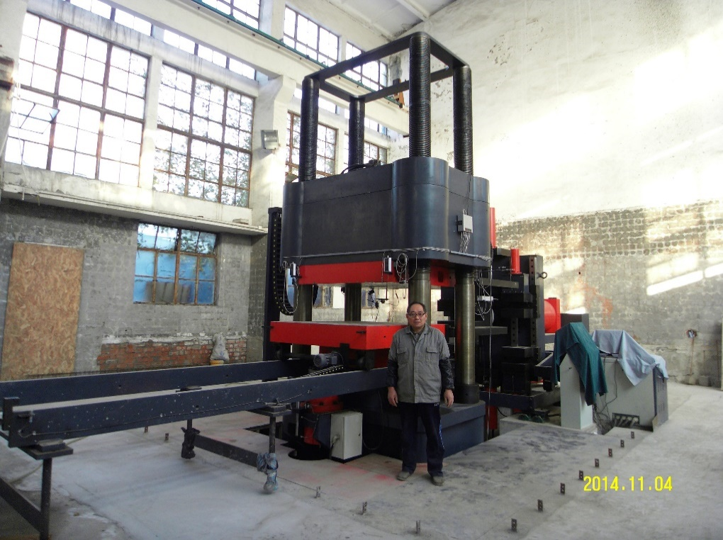
Test charge | About 3,000 ~ 20,000 RMB, according to the size of the rubber bearing.

#6 | 800kN Metal Damper Tester
Location | Siping Road Campus
Description | Especially equipped for metal damper test.
Capacities | Max. Shear Force (kN) | Displacement (mm)
Capacities | 800 | ± 200
Picture 1 | 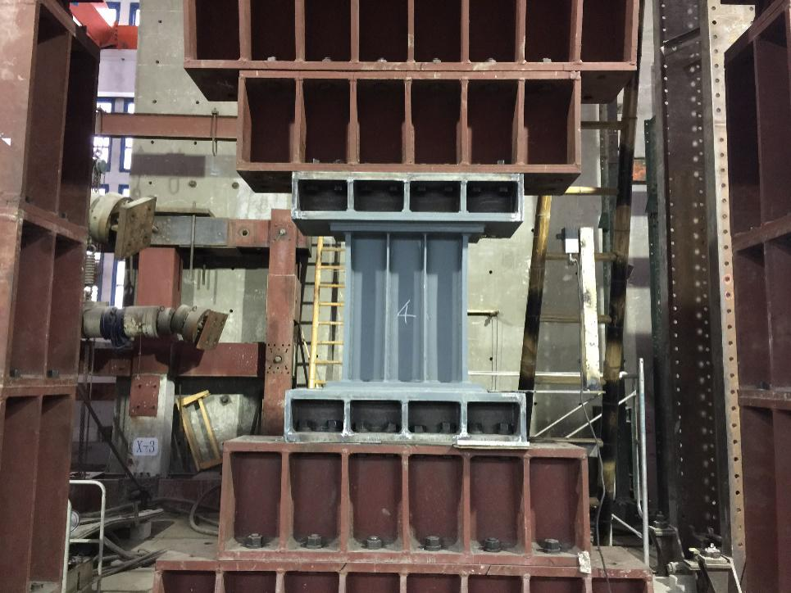  Metal damper tester
Test charge | 20,000 RMB per specimen.

#7 | Shaking table facility
Location | Siping Road Campus
Description | MTS shaking table.
Capacities | Dimension: 4.0 m×4.0 m  Highest payload: 25 Ton  Working frequency: 0.1~50Hz  Degree of freedom: 6 degree of freedom  Sampling channel: 128  Performance under 15 Ton payload
  Direction | Max acceleration | Mac Velocity | Max Displacement
  X | 1.2g | 1000mm/s | 100mm
  Y | 0.8g | 600mm/s | 50mm
  Z | 0.7g | 600mm/s | 50mm
Picture 1
Picture 2 | 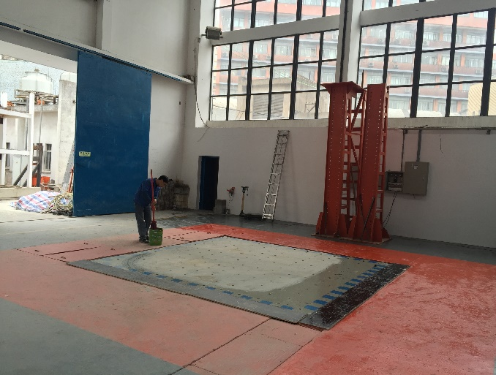
Test charge
   | Item | Cost
   | Lab space occupied fee | 3.125 RMB /square meter/day
  Table usage fee | Table usage fee (Occupied) | 2000 RMB/Day
  Table usage fee | Table usage fee (Testing) | < 40 channels: 20000 RMB/Table/Day
  Table usage fee | Table usage fee (Testing) | Channels < 80: 25000 RMB/Table/Day
  Table usage fee | Table usage fee (Testing) | Channels < 128: 32000 RMB/Table/Day
  Equipment rental | Strain | 80 RMB/Channel/Day
  Equipment rental | Displacement | 80 RMB/Channel/Day
  Equipment rental | Acceleration | 40 RMB/Channel/Day
  Other fee | Material testing | Full stress-strain curve: 100 RMB/Piece
  Other fee | Material testing | Only yield capacity: 30 RMB/Piece
  Other fee | Overtime fee (hours outside regular office hour 8 am -5 pm on weekday) | 300 RMB/Person/Day
  Other fee | Clean up fee | Case dependent

#8 | Centrifuge Shaking Table
Location | Siping Road Campus
Description | 1D Centrifuge Shaking Table
Capacities | Main specifications of Geotechnical Centrifuge  Main specifications of the Centrifuge Shaking Table
  Main Capacity | Effective radius | 3.0m
  Main Capacity | Max speed of rotation | 244rpm
  Main Capacity | Main motor | 250kW
  Main Capacity | Maximum acceleration | 200g
  Main Capacity | Maximum payload | 1.5MN
  Platform size | Length | 1.6m
  Platform size | Width | 1.25m
  Platform size | Height | 2.17m
  Data Acquisition | Static test | 40 channels
  Data Acquisition | Dynamic test | 32 channels
  Max. Acc. | a_{max}=20g
  Max. Velocity | V_{max}=38cm/s
  Max. Disp. | A_{max}=±6mm
  Frequency | f=20～200Hz
  Payload | M_{max}=300kg
  Wave | Sine Wave, Earthquake wave
  Time Duration | 1 second
Picture 1 | 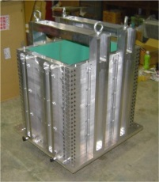  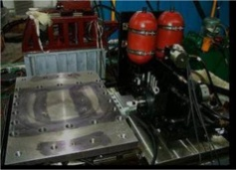  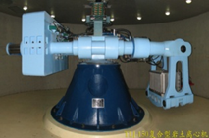  Geotechnical centrifuge 1D Centrifuge shaking table Laminar box
Test charge
   | Item | Cost
  Centrifuge test fee | Each test case | Above 9000 RMB each case (should be discussed on each specific case)
  Equipment rental | Strain | Should be prepared by clients
  Equipment rental | Displacement | Above 800RMB/channel (for laser displacement transducer)
  Equipment rental | Acceleration | Above 600RMB/channel

